Project of Biodiversity Conservation in Central Zagros Landscape
Final short report

Summer 2017

Abbreviations
Catchment Management Area | CMA
Conservation and Sustainable Development of Central Zagros Mountains | C+SD P
Central Zagros Mountains | CZM
Department of Environment | DoE
Efficiency Assessment | EA
Global Environment Facility | GEF
Implementation Assessment | IA
Memorandum of Understanding | MOU
Monitoring & Evaluation | M & E
National Project Director | NPD
National Project Manager | NPM
The 6th National Development Plan | The 6th NDP
United Nation Development Programme | UNDP
Zagros Mountains | ZM

For further information on details of studies, programs, actions taken by the Project, statistics, figures, maps, and graphs, please see the link below:
centralzagros.doe.ir

Index
Preface | 4
1. Project executive summary | 8
2. Legal support: national and international | 16
3. Vision, expected goals and outputs | 19
4. Overall process | 20
4.1. Achievement within the log frame | 20
4.2. GEF independent evaluation | 21
4.3. Financial overview at project closure | 24
4.4. Transfer of responsibilities | 25
4.5. Handover of assets | 26
4.6. Lesson learned and conclusion | 27
4.7. Recommendations and future steps toward sustaining … | 28

Preface
Zagros landscape encompasses more than 26% of the country, 50% of Iran forests, and 23% of the country’s rangelands, and is considered water tower of the country with supplying 45% of the total fresh water. The Zagros Mountains is regarded as the cradle of several ancient civilizations (cultural diversity) while inhabiting rich plant (2350 out of 10,000 species throughout the country) and animal resources (Iran is one of the twenty mega-biodiverse countries of the world). These mountains provide habitat and livelihood for 34% of the country population. Although sustainable development of such ecosystem is regarded a priority for GOIRI, in recent decades the Zagros biodiversity within protected areas and their outskirts has faced grave dangers caused by population growth, socioeconomic structure, lack of appropriate management approaches, and disappearance of traditional uses while being affected by unsustainable, unbalanced development. The consequences include increasing erosion rate, decrease in biodiversity, threat to habitats, loss of main wildlife corridors, and land-use change. The current resources use approaches need to change, otherwise many species will go extinct. In recent years, many relevant agencies in the area have carried out studies on sustainable development, and accordingly some measure has been taken; these, however, have not resulted in desired outcome in environmental terms. They have been carried out separately without engaging local communities, hence without significant effect on biodiversity conservation and ecological capacity. To address such an issue, Project of Biodiversity Conservation in Central Zagros Landscape (hereinafter Zagros Project/the Project) was put forward to develop and formulate a comprehensive management plan aiming at integrating biodiversity conservation and development in a process involving the entire stakeholders and authorities across Central Zagros with an area of 3,100 million hectare. It pursued consolidating biodiversity conservation and development through thorough stakeholder participation. Its main aim was sustainable management of the area by mainstreaming biodiversity conservation into sustainable use of agricultural, forest, rangeland, tourism, and surface and underground water resources as well as into socioeconomic development programs. The relevant management patterns were designed in a fashion that helps realize sustainable development at macro scale, strengthen livelihoods of the people benefitting from natural resources, and serve as economic incentives.
Zagors Project was a joint initiative by GOIRI, GEF, and UNDP launched in 2005 and directed by DOE. It ended in Jan 2017, in accordance with the decision of the Steering Committee and verification from NPD as well as UNDP.
This booklet contains a brief discussion on the above mentioned context and the corresponding project achievements in respond to the following threats and challenges.
The main challenges and threatening factors affecting biodiversity within the catchment management areas in Central Zagros are as follows:
- Unsustainable agriculture
- Unsustainable use of Rangelands
- Unsustainable use of water resources
- Weakness in management of natural - areas
- Unsustainable use of forests
- Unsustainable aquaculture
- Socio-economic challenges
- overexploitation of biodiversity products
- Inadequate public awareness about and lack of participation in environmental and biodiversity conservation.
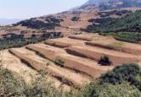
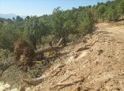

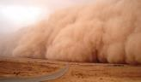
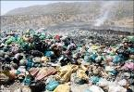

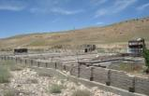
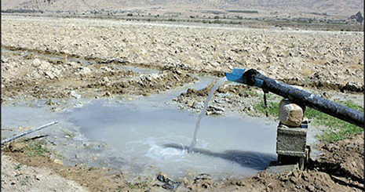
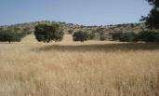
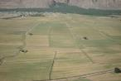
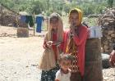
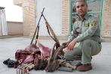

Figure 1: threats and challenges of CMAs

Zagros Project tried to address opportunities, threats, strengths, and weaknesses. Accordingly, a management system was designed to improve biodiversity, conserve natural resources, and sustain current uses.

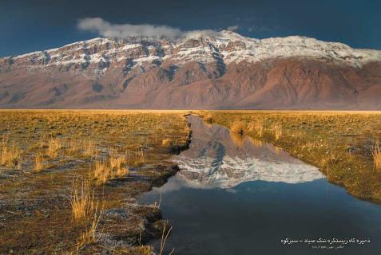
Figure 2: natural landscape in Central Zagros

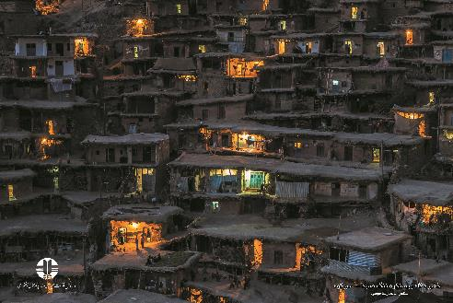
Figure 3: human landscape in Central Zagros

According to project logical frame (log frame), the outcomes and outputs of the Zagros Project are summarized in Chart 1.
Output 1.1: National and Provincial Institutional and Policy Framework in place
Output 3.1: Completion of establishment of four pilot Management Areas; complete Evaluation of pilot program
Output 3.2: Support implementation of Pilot Management Programs in 4 Areas
Output 3.3: Support priority conservation and livelihood actions
4.1: Central office and staff
4.2: Short-term Consultants
4.3: Exit strategy: Project information management, monitoring, reporting & evaluation
Output 2.1: Zagros Mountains C&SD Program is under implementation nationally and in the 4 Provinces.
Output 2.2: Multi-sector integrated strategies for Sustainability and Resilience within the C&SD Program
Output 2.3: Ten CZM Catchment Management Areas established; Integrated C&SD Programs are developed and implemented in initial 4 CMAs.

Chart 1: Project log frame, outcomes, and outputs

1. Project executive summary (2005 – 2017)
To deliver log frame, the following five steps were taken.

Step 1: baseline studies and pilots in target villages (2005 -2011)
- Studying and analysis of the 8 pilot villages
- investigating the state of biological regeneration of Central Zagros native birds, reptiles, amphibians, mammals, fish, butterflies and prominent plants in order to determine indicator species and introduce conservation strategies

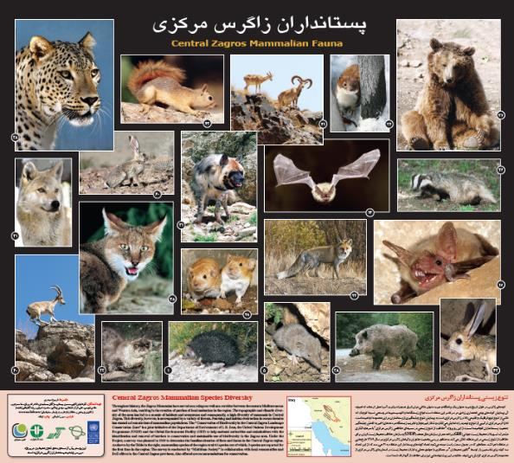
Figure 4: an instance of visual products form baseline studies – natural resources in Zagros

- Identifying the biodiversity hotspots in the Central Zagros conservation landscape
- Conducting research on the planning and budgeting mechanisms
- Stakeholder Analysis and Identifying threats to the pilot areas
- Conducting social and economic studies on stakeholders and communities of Central Zagros Mountains
- Conducting studies to identify the ecologically and environmentally friendly livelihoods in Central Zagros Mountains
- Creating a management structure: local committees and management support mechanisms

Step 2: Mid-term evaluation (2011)
Mid-term evaluation led to recommendations by independent international and national evaluators. These were introduced to a committee consisting of DOE, Ministry of Foreign Affairs, and UNDP that approved project extension, provided that:
- The log frame would be redesigned
- The goals in the preliminary project document would be refocused on
- The organizational chart of the Project would be revised

Step 3: completion, assessment, and scale-up of the project in pilot areas (2011 – 2014)
- Collecting baseline data, mapping, and investigating land-use conversion in Central Zagros by RS in GIS environment
- Ecological capacity evaluation studies and land-use zoning in Central Zagros
- Field studies on knowledge and awareness assessment of local community about biodiversity
- Exhaustive studies on water resources: meteorology, hydrology, underground water, and water consumption
- Studying environmental factors regarding contamination of the Iranian oak by fungi and assessing resistance of seedlings to diseases in Western Dena
- Training courses for stakeholders, local communities, relevant government agencies, and NGOs in scale-up areas on sustainable use methods concerning with sustainable tourism, ecotourism, sustainable agriculture, sustainable rangeland management, sustainable aquaculture, and sustainable forest use
- Developing and implementing an awareness-raising program to attract participation from stakeholders and relevant authorities
- Identifying biodiversity potential in Central Zagros conservation landscape and establishing an information system containing state of conservation of and use from current ecosystems
- Implementation of pilot projects dealing with biodiversity conservation and sustainable livelihood in pilot areas of Naghan-Boldadji, Western Dena, Dena-Vanak, and Kor-Kamfiruz
- Producing Zagros Virtual Tour Software in English and Persian
- Signing a memorandum of understanding by DOE deputy and four governors general

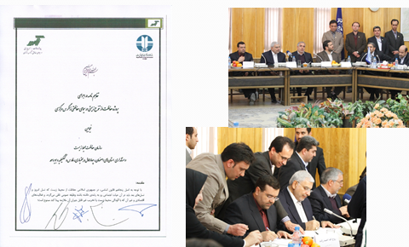
Figure 5: MOU in pilot areas

- Biodiversity Green Grant Scheme
- Establishing mountain biodiversity resource centers within portals of environment directorates general in four provinces and emission of information to the public
- Establishing management structure and management support mechanisms with a new scoping approach based on catchment management areas matching hydrological boundaries

Figure 6: map of the ten CMAs in Central Zagros

Table 1: summarized characteristic of CMAs
CMA code | Name of the CMA | Area (Hectares) | Province | Main counties with large area | Smaller Counties
1 | Kor | 469076 | Fars | Eghlid, Marvdasht, Sepidan | Abadeh
2 | Abadeh- eghlid | 276606 | Fars | Eghlid, Abadeh | -
3 | Lordegan | 276266 | Charmahal- Bakhtiari | Lordegan | -
4 | Vanak- khersan | 533651 | Isfahan | Semirom | Shahreza
5 | Boyerahmad | 221595 | Kohgiloyeh- Boyerahmad | Boyerahmad | Dena and Sepidan
6 | Dena | 205399 | Kohgiloyeh- Boyerahmad | Boyerahmad, Dena | Kohgiluyeh
7 | Broojen | 139632 | Charmahal- Bakhtiari | Boroojen | -
8 | Koohrang | 127790 | Charmahal- Bakhtiari | Koohrang | Ardal
9 | Bazoft | 420581 | Charmahal- Bakhtiari | Ardal, Koohrang, Kiar | Broojen and Lordegan
10 | Beheshtabad | 396472 | Charmahal- Bakhtiari | Shahrekord, Broojen, kiar | Farsan and Ardal

Step 4: development and operation of a long-term and macro-scale program: Conservation and Sustainable Development Program of Central Zagros Mountains (C+SD P) (2014 – 2015)
- Revising and updating economic, social, physical, and ecological information of CMAs
- Drafting Conservation and Sustainable Development Program of Central Zagros Mountains (C+SD P)
- Designing the relevant cross-cutting management structure (Figure 8)
- Establishing and operational zing the relevant executive committees and secretariats at national and province levels
- Developing, updating, and activating management toolkit involving:
  - Use zoning
  - Sustainable natural-resources-use practices
  - Monitoring program
  - Management information system and the relevant application
- Proposal and designation of two biosphere reserves under UNESCO’s Man and Biosphere Program: Sabzkuh-Tang Sayad and Dena
- Signing “MOU to Implement C+SD P P” by Deputy of Production Affairs, Planning and Budgeting Organization; Deputy of Urban and Rural Development, Ministry of Interior; Deputy of Natural Environment, Department of Environment; and four environment directors general from target provinces in the presence of Chief of Iran Department of Environment and UNDP Representative in Tehran (2/15/2016)

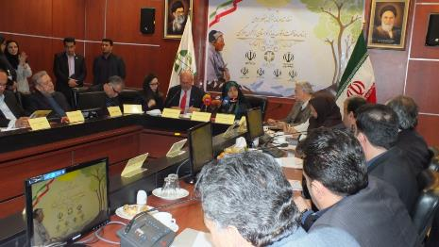
Figure 7: MOU to implement C+SD P

Figure 8: Central Zagros management structure
Chair
County Governors
(Periodic/Fixed-Term)Outcome1: National institutional and policy framework mainstreaming biodiversity into development in Central Zagros Mountains
MoAJ
Tourism
County Governors
DoEOutcome 3: Successful, sustainable, financially replicable model Management Areas demonstrates integration of resource sector sustainable development and livelihoods with conservation of biodiversity.

Water Affairs
Natural Resources Org.Outcome 4: Efficient technical support to all project activities, coordination, monitoring, advocacy and adaptive management.
CBOs
(2 reps.)
NGOs
(2 reps.)
Office of Mine Industry and Trade
Nomads Affair

Prov, Reps, of Fishery/
Housing Foundation/
Universities/ Education/
Urban Development/
Rural Cooperatives

ZMRC
Catchment Management Area Management Committee
Provincial Executive Secretariat
Deputy of Planning and Budget coordination
(Province Management Offices)
ُProvincial Planning and Development Council (Land use WG as CZM Provincial MC)
National Executive Secretariat

Director General of Sustainable Development Bureau in DoE
National Management Committee of Zagros Mountains
Chair
Deputy of Urban and Rural Development,
Ministry of Interior
Deputy of Water Affairs, the Ministry of Energy
Deputy of Mine, Industry and Trade Affairs Ministry
Deputy of the Natural Environment in DoE
Head of
FRWO
Deputy Minister of Roads and Urban Development
Deputy of Production Affairs in Management and Planning Organization
Deputy of the Investment Affairs in Cultural Heritage, Handicrafts and Tourism
Head of Nomad Affairs Organization
Deputy
Minister of MoAJ

Step 5: management system capacity development, terminal evaluation, and project exit (2015 – 2017)
- Development of concept notes: sustainable water (quality and quantity) management, forestry, wildlife, tourism, rangeland management, agriculture, aquaculture, climate change adaptation, Green Grant Scheme, and stakeholders’ capacity development and awareness raising
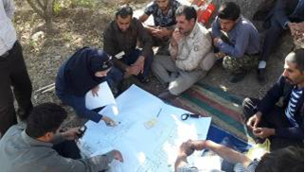
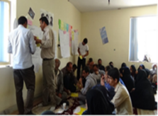

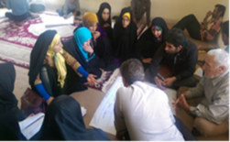
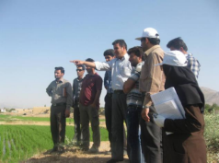

Figure 9: capacity development in Central Zagros

- reviewing C+SD P according to MAB Program (Lima Action Plan 2016-2025)
- Developing guidelines on indicator species conservation in Central Zagros (plants, invertebrates, and vertebrates), the relevant monitoring program, and a database containing monitoring and assessment information
- Annual work plan for capacity development and awareness raising on the part of stakeholders at province and local levels within CMA comprehensive plans (Vanak-Khersaan, Bazoft, Dena, and Kor)
- Production, publication, and distribution of CMA abstract information booklets
- Terminal evaluation by national and international evaluators
- Project extension for further six months (until middle 2017)
- Preparing an archive containing information produced during project lifespan and its handover to Deputy of Natural Environment, DOE
- Project closure and handover of responsibilities to GOIRI

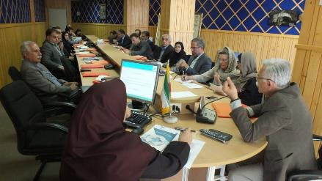
Figure 10: final Steering Committee meeting and handover of responsibilities and achievements

Chart 3 illustrates a schematic outline of the above mentioned steps. It is worth noting that CMA comprehensive plans are based on both participatory planning approach and ecosystem approach.

Conservation and development of Central Zagros (biodiversity mainstreaming)
Ecological approach
System approach
Identifying stakeholders
Identifying challenges and threats
Identifying values and opportunities
Facilitating stakeholder involvement
Cross-sector executive structure
Participatory implementation of management plans
Monitoring and feedback
CA comprehensive management plan
30-year vision
Main goal
Strategic goals
Action plans

Chart 2: roadmap of comprehensive management plan for CMAs

2. Legal support: national and international
The approach and strategic goals of Zagros Project relate closely to several high level documents, both national and international. It responds to and is in line with the major goals of sustainable development. Table 2 shows such a relationship.

Table 2: matching strategic goals of C+SD P and relevant national/international documents
Central Zagros Mountain Conservation and Sustainable Development Program Executive Strategies  (2016) | Article 38, Section 9, Sixth Development Plan (2017) | Article 32, Environmental Code in Development Plans  (2017) | NBSAP 2  (2016) | Aichi Biodiversity  Targets  (2011-2020) | Sustainable Development Goals  (2015) | UNDAF/ CPD
Conservation of the environment and biodiversity values | - Paragraph r  - Paragraph s |  | -Strategic Goal 1: All National Targets  - Strategic Goal 4  National Targets 16, 19 and 22 | -Strategic Goal C  Target 12  -Strategic Goal E  Target 17, 18 and 19 | - Goal 12, Target 12.2  - Goal 15, Targets: 15.4, 15.5, 15.8, 15.c  - Goal 17, Target 17.17 | UNDAF Output 1.1
Managing and controlling the impacts of the unsustainable activities and uses | - Paragraph b  - Paragraph e  - Paragraph g  - Paragraph h  - Paragraph i  - Paragraph k  - Paragraph m  - Paragraph q  - Paragraph v |  | -Strategic Goal 3  National Targets 9, 10 and 13  -Strategic Goal 4  National Targets 18, 20 and 21 | -Strategic Goal B  Target 5 and 7  -Strategic Goal C  Target 13  -Strategic Goal D  Target 14 and 15 | - Goal 6, Targets: 6.4, 6.5, 6.6, 6.b  - Goal 7, Targets: 7.1, 7.2, 7.a  - Goal 15, Targets: 15.1, 15.2, 15.b
Managing and controlling the impacts of the unsustainable activities and uses | - Paragraph j  - Paragraph t |  | -Strategic Goal 3  National Targets 9, 10, 12 and 14 | -Strategic Goal B  Target 6, 7 and 9 | - Goal 8, Target 8.9  - Goal 12, Target 12.b  - Goal 14, Target 14.4, 14.6  - Goal 15, Target 15.3
Sustainable development in the process of resource use | - Paragraph a  - Paragraph l  - Paragraph n | - 2, 3, 4 | -Strategic Goal 1  National Targets 1, 4 and 5  -Strategic Goal 2  National Targets 7, 8, 12, 13  -Strategic Goal 4  National Targets 16 and 23 | -Strategic Goal B  Target 6 and 8  -Strategic Goal E  Target 19 and 20 | - Goal 12, Target 12.2  - Goal 13, Target 13.1, 13.2  - Goal 15, Target 15.3, 15.9, 15.a  - Goal 17, Target 17.7 | - UNDAF Output 1.1  - CPD Output 1.1
Conservation and rehabilitation of the cultural values and vision of the CZM | - Paragraph f |  | -Strategic Goal 1  National Target 3  -Strategic Goal 3  National Target 15 | -Strategic Goal E  Target 18 and 19 | - Goal 9, Target 9.a  - Goal 11, Target 11.6  - Goal 12, Target 12.4, 12.5  - Goal 15, Target 15.1, 15.9  - Goal 17, Target 17.7, 17.17

3. Vision, expected goals and outputs
Within the project document exchanged between GOIRI and UNDP, Zagros Project undertook formulating a vision and the relevant main goal as well as strategic goals.

30-Year Vision of CZM
The Zagros Mountains is a unique area that enjoys sustainable, balanced development in a way that the stakeholders cooperate in its management while considering the carrying capacity of the nature and the life and water cycle; They also benefit from mountain endowment fairly, dynamically and sustainably where both the structure and function of the Zagros Mountain’s ecosystem will be preserve for the future generations.
Main Goal
Sustainable development and conservation of natural and biodiversity resources in CZM
- Conservation of the current biodiversity and health of the ecosystems
- Promoting the conservation and restoration of wildlife in the region and the qualitative and quantitative development of the wildlife management plan
- Awareness raising and participation of decision-makers, civil society organizations and people for the conservation of biodiversity values

- Conservation, restoration, reconstruction of rangelands' ecosystems in CZM
- Conservation, restoration, reconstruction of forests' ecosystems in CZM
- Conservation of the quantitative and qualitative characteristics of water resources in water ecosystems (rivers and wetlands)
- Developing sustainable agriculture for controlling or reducing the threats in agricultural activities
- Sustainable development of aquaculture and sustainable use of fisheries resources
- Sustainable tourism development through the control or reducing the threats of tourism activities
- Establishment and improvement of regional planning and developing management tools of CZM
- Adjusting policies, laws, regulations and policy advocacy to conserve the CZM
- Developing strategic environmental assessment
- Improving and strengthening the Major Green Initiatives

Conservation of the environment and biodiversity values
Restoration and rehabilitation ecosystems in degraded areas
Managing and controlling the impacts of the unsustainable activities and uses

Sustainable development in the process of resource use
Conservation and rehabilitation of the cultural values and vision of the CZM
Strategic Goal 1
Strategic Goal 2
Strategic Goal 3

Strategic Goal 4
Strategic Goal 5
- Conservation and restoration of the values and native culture and Eco-friendly traditions
- Conservation, restoration and rehabilitation of the CZM landscapes and vision

Chart 2: outline of the vision, main goal, and strategic goals in C+SD P

4. Overall process

4.1. Achievements within the log frame
Since the major goal of the log frame was defined as “improvement in socioeconomic development and mainstreaming biodiversity conservation into socioeconomic activities in Central Zagros” – as stipulated in the project document exchanged between GEF and GOIRI – accordingly the achievements are illustrated in Table 3.

Table 3: outcome vs. results and achievements by the Project
Expected Output 1:
Establishment of an integrated legal structure and policy framework in order to implement biodiversity conservation in development activities;
- Achievements/results
Development of Conservation and Sustainable Development Program of Central Zagros Mountains, a long-term program, and its relevant cross-cutting management structure at national and province levels based on an M&E program that indicates impact of plans and reports existing environmental state across Central Zagros in order to plan and act toward sustainable natural resources.
Expected Output 2:
The institutionalization of Sustainable use and conservation of biodiversity in economic sectors and development plans in CZM
- Achievements/results
- 6th National Development Plan: Chapter 9, Article 38, paragraphs a, b, e, g, h, i, j, k, l, n, m, q, r, s, t, v
- Compliance with the four strategies and 22 national action plans stipulated in National Strategic Action Plan on Biodiversity (2017 – 2021)
Expected Output 3:
successful integration and implementation of sustainable, funded models that are replicable in Central Zagros, and indicate integrated sustainable development regarding natural resources and biodiversity
- Achievements/results
Entirely Successful implementation of the relevant commitments by GOIRI at local level through Green Grant Scheme with an approach involving sustainable management of natural (fauna, flora, biodiversity), physical (water, air, soil), and economic resources, replicable across the whole Zagros vegetation area. This was eventually scaled up to Green Initiatives involving various components, i.e. sustainable agriculture, sustainable tourism, sustainable forestry, integrated range management, and sustainable wildlife management, pivoting around local community participation and with the legal support from 6th National Development Plan.

4.2. GEF independent evaluation
The final achievements and results fulfilled by the Project were audited in the summer of 2016. This was processed through a tender invitation calling for national and international bidders. After conducting the selection process and legal arrangements associated with the contract signage, evaluators undertook investigating and rating the Project implementation (Table 4).

Table 4: evaluation and rating the implementation of Zagros Project
EVALUATION CRITERIA | RATING | COMMENTS
Monitoring & Evaluation
M&E design at entry | Satisfactory (S) | A Monitoring Plan is described and budgeted in the project document.
M&E Plan Implementation | Unsatisfactory  (U) | The Monitoring Plan has not been implemented for the most part.
Overall quality of M&E | Moderately Unsatisfactory (MU) | Monitoring in general has not been systematic. A Mid-Term Evaluation was held at a late stage, yet has had significant influence on project design and strategy. The UNDP CO has monitored the project with several visits by assigned focal points. UNDP’s RBAP Regional Office in Bangkok organized several monitoring visits. Provincial project officers performed ad hoc internal monitoring. More consistent and in-depth monitoring might have encouraged adaptive management to improve performance at an earlier stage.
IA and EA Execution
Quality of UNDP implementation | Moderately satisfactory (MS) | UNDP has provided periodic technical oversight through the Country Office and RBAP Regional Office, contributed TRAC funding to support project implementation, and organized a very useful Mid-Term Evaluation that should have been scheduled 2 years earlier. The CO supported the project’s continuity when performance was unsatisfactory. However, the project would have benefited from more consistent oversight and guidance from UNDP and BD conservation mainstreaming case studies through UNDP’s global knowledge network.
Quality of DoE execution | Moderately Unsatisfactory  (MU) | Execution quality has been inconsistent and generally slow, with low financial and output delivery rates. The project took twice as long to complete than was planned. Management practices were not applied regularly during the first five years and the project implementation approach lacked strategic direction. Execution was undermined by excessive turnovers of NPDs, NPMs and technical staff. The Project Steering Committee has not provided the technical guidance and oversight that was expected. DoE does not have the over-arching institutional coordination or planning mandate that is needed to influence GO or sector practices. However, there have been improving trends in management performance and project delivery during recent years and more than half of the planned outputs have been delivered.
Overall quality of implementation/execution | Moderately Satisfactory (MS) | The rating is largely based on improved project team performance and output delivery since 2014.
Assessment of Outcomes
Relevance | Satisfactory | The CZM region has recognized high biodiversity and continues to face the environmental threats that the project has tried to address. The project’s operational relevance was improved with changes introduced to the implementation strategy following the MTE.
Effectiveness | Moderately Satisfactory | The project objective was not achieved and there was limited progress towards the first and second outcomes. Satisfactory progress was made towards the achievement of the third outcome. Most outputs will be produced by the end of the project; although many have come at a late stage, limiting their impact. Output delivery and overall effectiveness improved during the final years of the project.
Efficiency | Unsatisfactory | Project implementation was slow and potential impacts were undermined by slow delivery. The project has taken ten years to complete, twice as long than was initially planned.
Overall Project Outcome rating | Moderately Satisfactory. | This rating is largely based on improved project performance and output delivery during the past three years, and the encouraging progress observed in some provinces.
Sustainability
Financial Resources | Moderately Likely | There is a moderately high likelihood that continued funding will be available to build on project initiatives. Interim financing appears to be available to extend essential activities beyond the project’s termination until the expected approval of the C+SD P programme. Financial sustainability will ultimately depend on the approval of the C+SD P. Supportive policies and national budget allocations under the 6th National Development Plan may improve perspectives for this to happen. Several of the small grant initiatives that were supported by the project are self-sustaining in financial terms.
Socio-Political | Moderately Likely | The C+SD P programme proposal was endorsed by the four provincial Governor Generals. There is proposed legislation that would provide special attention to high BD ecosystems facing environmental degradation under the 6th National Development Plan.
Institutional Framework & Governance | Moderately Unlikely | The PPDCs and new CMA inter-sectoral committees will require further technical support and guidance to drive biodiversity conservation mainstreaming processes. The CMACs were recently created and lack operational mechanisms.
Environmental | Likely | The project has not had an environmental impact on the scale that was envisioned. A few small demonstration grants have generated localized environmental benefits and have a strong replication/up-scaling potential.
Overall Likelihood of Sustainability | Moderately Likely | Sustainability will depend to a large extent on the approval of the C+SD P proposal in its final version, and the adoption of supportive policies under the 6th National Development Plan.
The rating criteria for terminal evaluations of UNDP-GEF projects is based on the following:
Ratings for Outcomes, Effectiveness, Efficiency, M&E, Agency Implementation and Execution:

6: Highly Satisfactory (HS): The project had no shortcomings in the achievement of its objectives in terms of relevance, effectiveness, or efficiency
5: Satisfactory (S): There were only minor shortcomings
4: Moderately Satisfactory (MS): There were moderate shortcomings
3. Moderately Unsatisfactory (MU): The project had significant shortcomings
2. Unsatisfactory (U): There were major shortcomings in the achievement of project objectives in terms of relevance, effectiveness, or efficiency
1. Highly Unsatisfactory (HU): The project had severe shortcomings
Sustainability Ratings:
4. Likely (L): Negligible risks to sustainability
3. Moderately Likely (ML): Moderate risks
2. Moderately Unlikely (MU): Significant risks
1. Unlikely (U): Severe risks
Relevance Ratings:
2. Relevant (R)
1. Not relevant (Nr)
Impact Ratings:
3. Significant (S)
2. Minimal (m)
1. Negligible (N)

4.3. Financial overview at project closure
The information below is a break-down of the Project finances at closure (in US$, unless stated).
- GOIRI covered 230% more than committed shared national co-financing, including all cash and in-kind expenditures.
- Expenditure of the GEF budget is 99.94%
- Expenditure of the UNDP TRAC funds is 98.24%

Table 5: Total Government, TRAC and GEF funding budgeted and utilized by the project
(June 2017)
Fund | Total Budgeted  USD $ | Year | Funds Utilised (2005-June 2017) | Un-used Balance
IRI. GOV | 5,725,000 | 2005-2017(June) | 13,193,669 | 230%
GEF | 3,800,0000 | 2005-2017(June) | 3,799,939 | 99.94%
UNDP- TRAC | 50000 | 2005-2017(June) | 49123 | 98.24%
TOTAL | 9,575,000 | 2005-2017(June) | 17,043,328

In order to clarify expenditure based on budget categories normally used by UNDP, Table 6 provides a summary of how the TRAC and GEF funding lines have been spent.

Table 6: TRAC and GEF Expenditure according to UNDP budget lines (Dec. 2015)
Budget Categories | TRAC and GEF Funds Utilised during 2005-2017(June) | Percentage of Total TRAC & Utilised ($ mil)
Human Resources (including consultants) | 2,006,436 | 52.12
Travel | 318,261 | 8.27
Equipment | 167,813 | 4.36
Contract | 885,193 | 22.99
Audio and visual Printing | 105,601 | 2.74
Others | 366,352 | 9.52
Total | 3,849,656.00 | 100%

4.4. Transfer of responsibilities
Over the life of the Project, many new and innovative activities have been successfully piloted. The development of integrated management plans at CMA level, as well as the CZM Conservation and Sustainable Development Program (CZM C+SD P) at semi national level bring new and ongoing responsibilities, particularly for the Ministry of Interior, Planning and Management Organization and Department of Environment. The Project has made strong efforts, through its Exit Strategy, to ensure that the new approaches and responsibilities can be adopted by national partners and rolled-out into the Zagros Mountain management system for the whole area. This process has been achieved through:
- Preparation and approval of Project Exit Strategy by Project Board. And as a part of the staff exit strategy, some of the contracts of the personnel were stopped or changed to part-time contracts and there were several negotiations to use the capacity of project staff within DOE and PMO which resulted in recruitment of at least 1 provincial technical expert in related provincial DoEs’.
- The handover plan was developed and implemented for sharing project products, achievements and lessons to national, provincial and catchment executive agencies/ key stakeholders.
- Developing 2016-2017 Joint Annual Work Plan for capacity development of CZM management system between Zagros Project and CZM Executive Secretariats, and conducting several training courses on Zagros integrated and collaborative management in national, provincial and catchment levels.
- Transfer of project responsibilities to PMO (national and provincial levels) for: a) developing new management plans for the rest of 6 CZM CMAs, b) developing and implementing 10 CMA Annual Work Programs, c) resource mobilization and implementation of Green Grant Scheme, and d) Apply and develop CZM Management Toolkit.
- Transfer of project responsibilities to DoE for managing Zagros Mountain Resource Centers and uploading, maintenance and updating CZM Management Information.
- Submission of CZM Conservation and Sustainable Development Program (CZM C+SD P P)
- Preparation of a scale- up strategy and estimate required budget for establishment of CZM management system by national and provincial executive secretariats through 6th IR National Development Plan.

4.5. Handover of assets
The list of project assets and proposed destinations was prepared and approved by NPD. The key assets and their destinations are as follows:
- Project vehicles – has been delivered to DoE, but will be in use by the project until the end of Scale-up phase
- Project Central office equipment, computers etc. – to be transferred to DoE, but will remain in the office until the end of Scale-up phase
- Project Provincial offices equipment, computers etc. – to be transferred to provincial PMOs
- Zagros Mountain Resource Centers– to be transferred to DoE in four provinces as main responsible unit
- Zagros Information Management System and its application – transferred to DoE Headquarters with IT bureau as main responsible unit
- Zagros Management Toolkit – transferred to Executive Secretariats (national and provincial levels)

4.6. Lesson learned and conclusion
- Achieving the ultimate goal of Zagros Project relies on capacity development, education, and key stakeholder participation, the especially local community, in sustainable management of the ecological resources used by them
- Mainstreaming biological resources conservation at watershed scale regarding activities associated with major economic sectors (agriculture, water management, forestry, rangeland management, tourism, energy, and infrastructure development) is feasible through a road map approved by relevant agencies and based on high level documents. Integrated Sustainable use activities and conservation will be successful, provided that sector policies, projects, and operations are directed through a consolidated management system.
- Conservation and sustainable development model is a viable alternative to sector management through allowing for sustainable development where civil society needs are met within carrying capacity and biodiversity conservation requirements are incorporated by users into development activities. This has been piloted at small scale by local communities supervised by policy makers, planners and government executive entities and the results were formulated as C+SD P approved by the executive government agencies.
- Establishment of cross-sector committees (CMA committees) is considered a significant lesson learned in terms of developing and employing modern integrated conservation and use mechanisms associated with biological resources utilization.
- Ratification of the 6th National Development Plan, into which an integrated management approach is embedded, provides institutional and policy capacity for enhancing biodiversity conservation under a macro-scale initiative.
- Green initiatives proposals, prepared and supported by key users and legal backed up by Article 38 of the 6th NDP, can moderate major environmental hazards causing long term implications
- Green Grant Scheme model and its implementation indicates change from sector management to cross-sector management. Sustainability and its implementation by local communities is guaranteed thanks to long-term Green Initiatives supported by the 6th NDP.
- As stipulated in the 6th NDP, GOIRI co-financing in international environmental projects jointly conducted by foreign governments as well as legal and natural persons is a great opportunity to attract volunteer support and investment that can be used to guarantee the Project legacy after its closure.

4.7. Recommendations and future steps toward sustaining the Project achievements
- in line with operationalizing Strategic System for Land Development (Article 32 in the 6th NDP), it is recommended that:
  - Monitoring development projects at national, province, and local levels in Zagros be based on C+SD P, which was developed in accordance with Clause 3 of Article 32 to address a cross-cutting approach, and be put on the agenda of Supreme Council of Land Use Planning and set an executive priority by its Secretariat (PMO).
  - Since DOE is in charge of reporting the state of the environment, the C+SD P executive secretariat be stationed in DOE to monitor government agencies’ compliance with C+SD P monitoring program.
  - As Chief of DOE is a member of Supreme Council of Land Use Planning, and in accordance with Zagros Project outcomes, a thematic workgroup, i.e. C+SD P workgroup, be set up to operationalize land use planning in Zagros.
  - An action plan for climate change adaptation across Zagros be considered as a priority regarding land development projects. This plan should be in harmony with overall planning orientation of the area and take into account the existing critical conditions.

- An integrated management mechanism for biological resources sustainable use be considered a priority in economic and job creation plans to diminish pressure on Zagros resulting in unsustainability through drought, forest and rangeland fires, erosion, underground water loss, destructive floods, overconsumption of freshwater resources in agriculture, unsustainable use of wildlife, desertification, inefficient wastewater and waste management, etc.
  - Introducing incentives to national executive entities in 12 Zagros provinces in compliance with Paragraph c under Note 4, Article 32; this needs to be simultaneous with the initiation of the 6th NDP. Such incentives were piloted successfully by Zagros Project.
  - Evaluation of ecosystem services of Zagros ecosystem needs to be compensated when these are consumed by development projects.

- Given the opportunity provided by the 6th NDP that guarantees a mechanism to supply GOIRI share in international environmental projects and schemes, a code of conduct should be defined and be followed when MOUs are signed in joint with international entities.

As listed in the Guidance for Terminal Evaluations of UNDP-supported, GEF-financed Projects (UNDP, 2012)

